Linux basic commands

1. User Management & File Inspection
Write a Bash script that creates a new user, sets a password, and verifies the user’s entry in /etc/passwd using grep. What command would you use to check the file type before opening it?
PROGRAM:
!/bin/bash

#Giving value to variable
USERNAME=$1
PASSWORD=$2

#New username created and added
sudo useradd $USERNAME

#Set user Password
echo "$USERNAME:$PASSWORD"|sudo chpasswd

#checking the password
grep "^$USERNAME:" /etc/passwd

#file open checking
if [ $? -eq 0 ]
then
echo "User $USERNAME successfully created."
else
echo "User creation failed."
Fi
OUTPUT
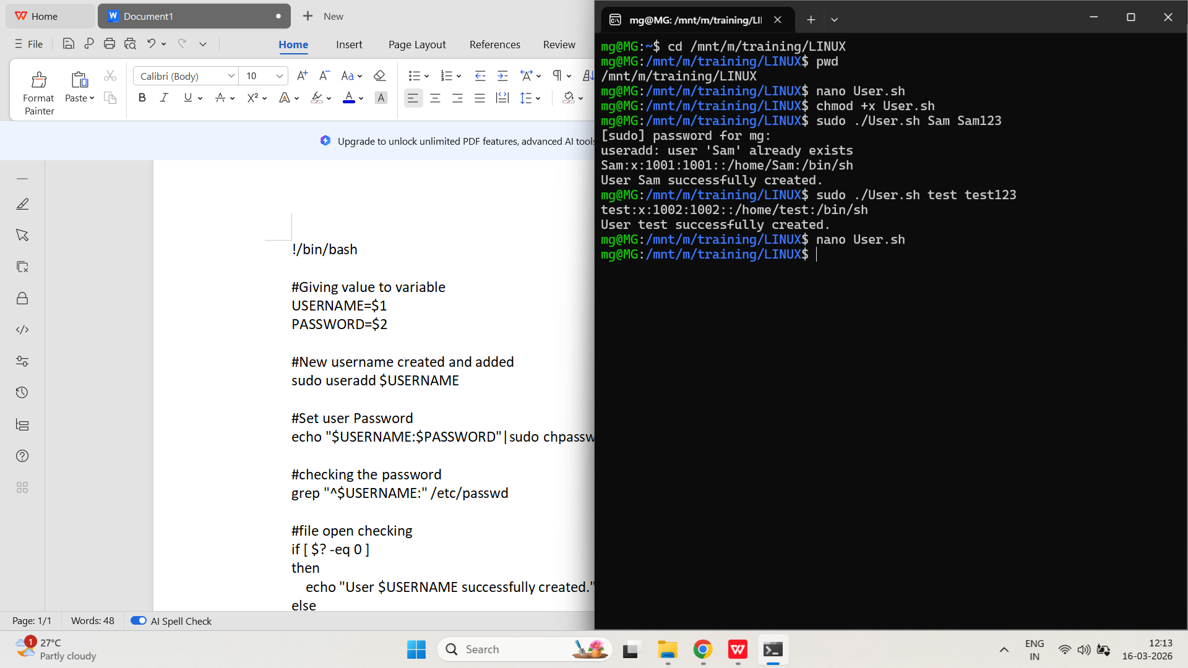
2. Environment Variables and Shell Configuration
Modify .bash_profile to include a custom greeting and a new environment variable. How would you ensure the variable is available in child shells?
PROGRAM:

echo "Welcome MG! Linux environment ready."

export TRAINING_PATH="/mnt/m/training/LINUX"
OUTPUT:
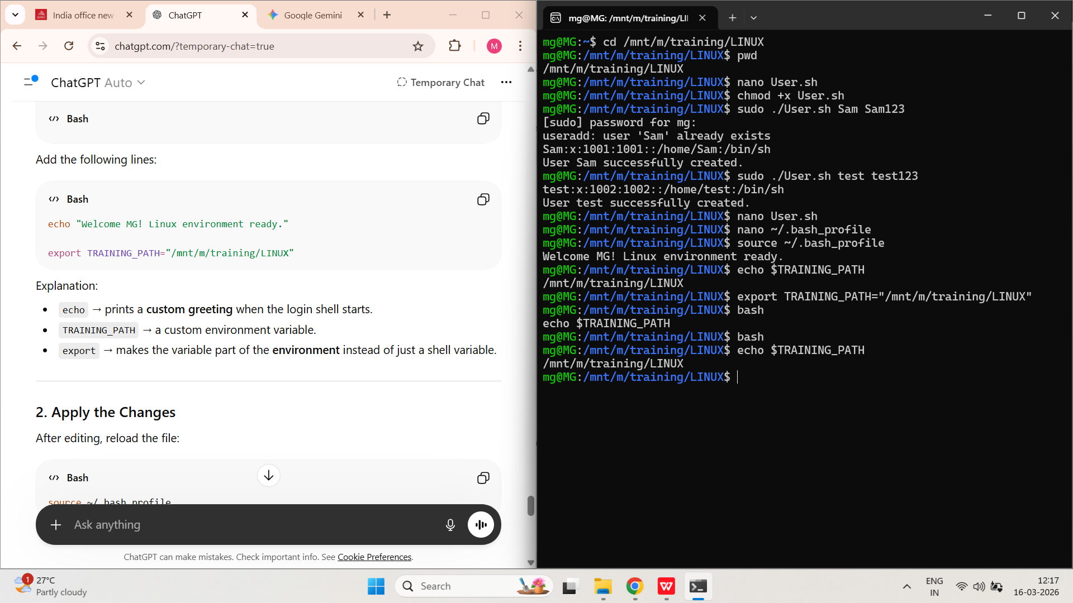
3. Redirection Operators
Create a script that collects system information using uname -a and ip a, and saves it to a file. Ensure that the output is appended, not overwritten. How would you redirect both STDOUT and STDERR to the same file?
PROGRAM:

#!/bin/bash

echo "System Information" >> system_info.txt
uname -a >> system_info.txt 2>&1

echo "Network Information" >> system_info.txt
ip a >> system_info.txt 2>&1
OUTPUT:
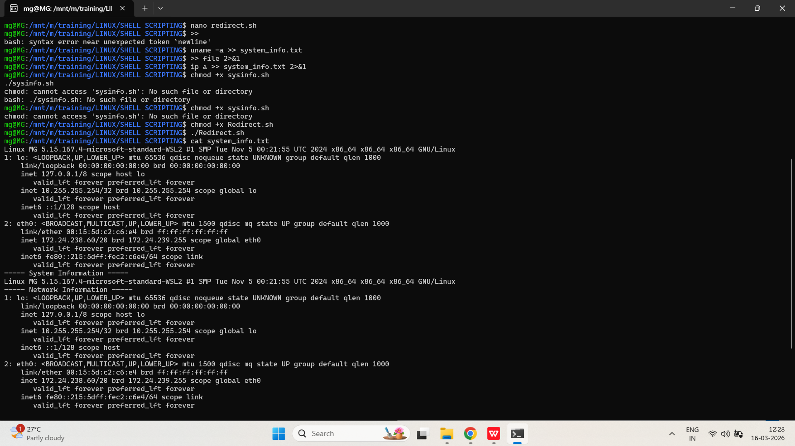
- Positional Parameters
Create a script that accepts four arguments: profession, age, city, and name. Use positional parameters to print a formatted sentence using these inputs.

PROGRAM:

#!/bin/bash

profession=$1
age=$2
city=$3
name=$4

echo "$name is a $age year old $profession living in $city."

OUTPUT:
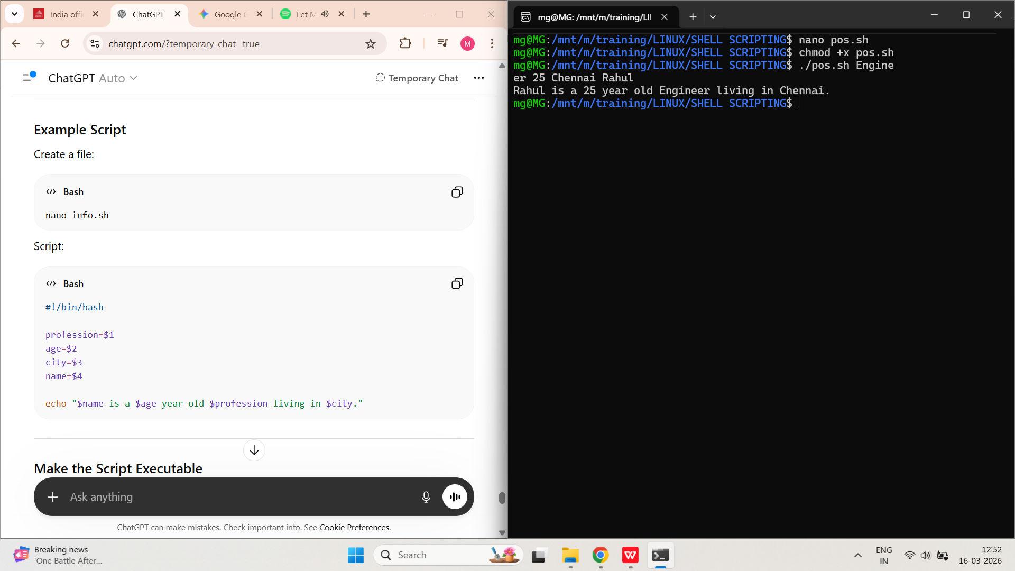

- Control Operators
Write a script that checks if a file exists and prints a message using &&. Then modify it to print a different message if the file does not exist using ||.

PROGRAM:

#!/bin/bash

FILE=$1

[ -f "$FILE" ] && echo "File exists."
#!/bin/bash

FILE=$1

[ -f "$FILE" ] && echo "File exists." || echo "File does not exist."

OUTPUT:
